**Method Overriding**

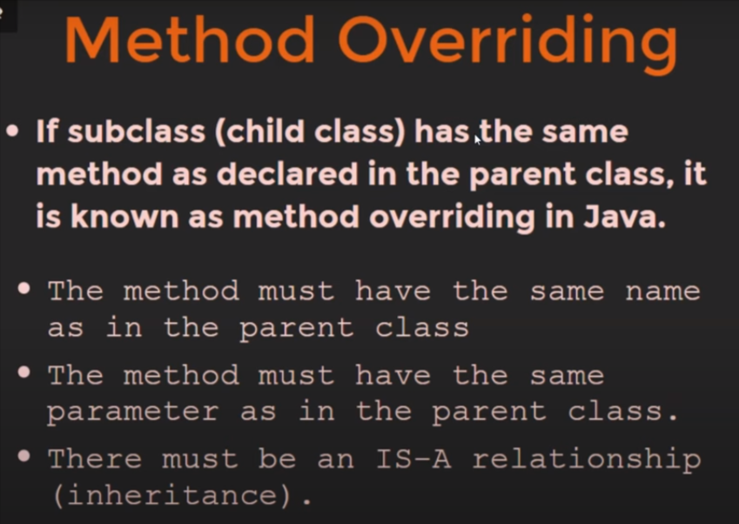

Same Parameter, means number of arguments should be same.

In method overriding, method of child class get override method of parent class.

**Example:**

class User{

void getLogin(){

System.out.println("User Loged-in");

}

}

class Emp extends User{

void getLogin(){

System.out.println("Employee Loged-in");

}

}

public class Main {

public static void main(String[] args) {

Emp emp = new Emp();

emp.getLogin("data");

}

}

**Output:**Employee Loged-in